**Practical Problems 1 – Basic Commands**

1. In MATLAB, create vectors **x** = (1,2,3,4,5) and **y** = (1,2,3,4,5) using any two different methods.

| Use the colon operator for one. Use the linspace() command for the other. Alternatively you could set *y* equal to *x*. |
| --- |

1. Add the two vectors together and examine the output.

| ans =  2 4 6 8 10 |
| --- |

1. Sum the elements of the answer to question 2.

| ans =  30 |
| --- |

1. Add the 3rd element of x to the last element of y, and assign the output to the variable z.

| z =  8 |
| --- |

1. Replace the 4th element of x with 7.

| x =  1 2 3 7 5 |
| --- |

1. Extend the vector y with the value 6 so that it has 6 elements.

| y =  1 2 3 4 5 6 |
| --- |

1. Shorten the vector y by assigning the empty matrix to element 3.

| y =  1 2 4 5 6 |
| --- |

1. Create three column vectors of length 3 named c1, c2, and c3. Create a 3x3 matrix called **A** using these column vectors.

| (example solution - your numbers may be different) >> A = [c1 c2 c3]  A =  1 4 7  2 5 8  3 6 9 |
| --- |

1. Calculate the determinant of the matrix **B.  
     
   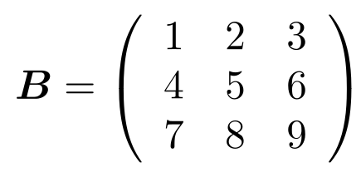**

| The answer should be approximately 0. Something similar to:  ans =  -9.5162e-16 |
| --- |

1. Calculate the eigenvalues of the matrix **B.**

| ans =  16.116843969807043  -1.116843969807042  -0.000000000000001 |
| --- |

1. Create a row vector,  
     
   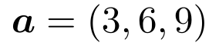  
   and a column vector,  
   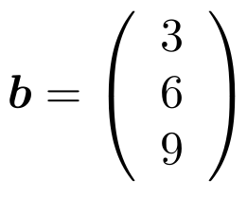
2. Perform matrix and then element-wise multiplication on these two vectors. Can you explain the error in the second case if your Matlab version is before 2017, or can you explain what is happening in later versions of Matlab?

| Matrix multiplication gives:  ans =  126  Element-wise multiplication gives (after Matlab 2017):  ans =  9 18 27  18 36 54  27 54 81 |
| --- |

1. Transpose the vector **a** and create a 3x2 matrix called **myMat** using it with **b**.

| myMat =  3 3  6 6  9 9 |
| --- |

1. Add the second element on the first row to the first element of the second row.

| ans =  9 |
| --- |

1. Create a random 2x2 array of non-integer numbers and give it a name.

| Use the rand() function (example solution - yours may be different)  x =  1.3868 2.3765  3.4278 6.6614 |
| --- |

1. Round the array to the nearest integer.

| Use the round() function (example solution - yours may be different)  ans =  1 2  3 7 |
| --- |

1. Find the number of elements in the array.

| Use the numel() function  ans =  4 |
| --- |

1. Find its maximum and minimum values.

| Use the max() and min() functions  (example solution - yours may be different)  ans =  7  ans =  1 |
| --- |

1. Find the maximum value on the 2nd row using a single command.

| Input only the 2nd row into the max() function  (example solution - yours may be different)  ans =  7 |
| --- |

1. Create a random vector of non-integers of length 8 and give it a name.

| (example solution - yours may be different)  z =  12.8846 0.7375 10.3300 3.7677 5.9197 7.6702 13.1983 5.8484 |
| --- |

1. Sort the vector into ascending order.

| (example solution - yours may be different)  z =  0.7375 3.7677 5.8484 5.9197 7.6702 10.3300 12.8846 13.1983 |
| --- |

1. Round the 2nd, 4th, 6th and 8th elements **up** to the nearest integer, and the 1st, 3rd, 5th and 7th elements **down** to the nearest integer.

| (example solution - yours may be different)  z =  0 4 5 6 7 11 12 14 |
| --- |

1. Generate a random 9x9 matrix of integers called **C**.

| (example solution - yours may be different)  C =  25 25 25 16 25 17 14 12 13  10 7 7 8 20 4 19 22 5  19 4 22 12 11 13 19 19 9  18 16 18 16 16 10 18 25 7  15 23 12 9 6 7 4 15 10  19 18 8 10 23 7 5 11 13  18 8 13 17 23 13 11 6 15  7 12 14 9 21 6 15 17 14  6 14 6 22 9 17 18 21 23 |
| --- |

1. Add the 4th column of **C** to the 6th column.

| (example solution - yours may be different)  ans =  33  12  25  26  16  17  30  15  39 |
| --- |

1. Create a 3x3 matrix **D** from the top left minor of matrix **C**, and a matrix **E** from the bottom right minor of matrix **C**.  
   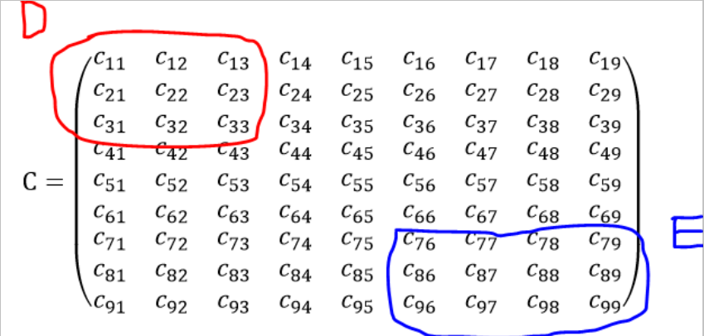

| (example solution - yours may be different)  D =  25 25 25  10 7 7  19 4 22  E =  13 11 6 15  6 15 17 14  17 18 21 23 |
| --- |

1. Perform the element-wise multiplication **DE** and **ED**.

| Matlab produces an error for these operations since the dimensions don’t match. |
| --- |

1. Perform the matrix multiplication **DE** and **ED**.

| (example solution - yours may be different)  DE produces:  ans =  900 1100 1100 1300  291 341 326 409  645 665 644 847  ED produces an error. |
| --- |

1. Create two character arrays of the same length (number of letters) called s1 and s1.

| (example solution - yours may be different)  s1 =  'lorem'  s2 =  'ipsum' |
| --- |

1. Create a new character array s3 by concatenating s1 with s2.

| (example solution - yours may be different)  s3 =  'lorem ipsum' |
| --- |

1. Sort the character array s3 into alphabetical order.

| (example solution - yours may be different)  s3 =  ' eilmmoprsu' |
| --- |

1. Create a vector **x** = (1,2,3,4,5,6,7,8).
2. Create a vector **y** = 2**x**.
3. Plot **y** against **x**.  
   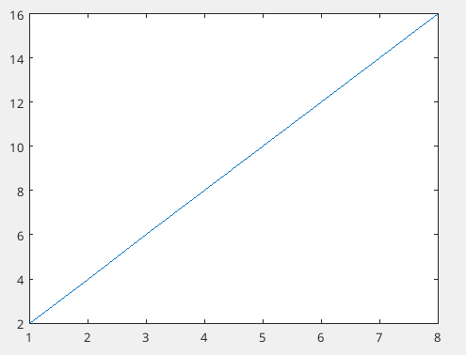
4. Create a vector of 100 points from 0 to π called *x*.
5. Plot **y** = sin(**x**).  
   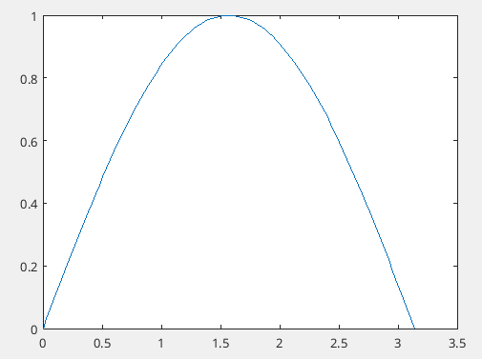
6. Find out in the documentation how to change the line colour and style (change as you see fit).  
   